World Water Day 2022
Realising the benefits of Scotland’s waters
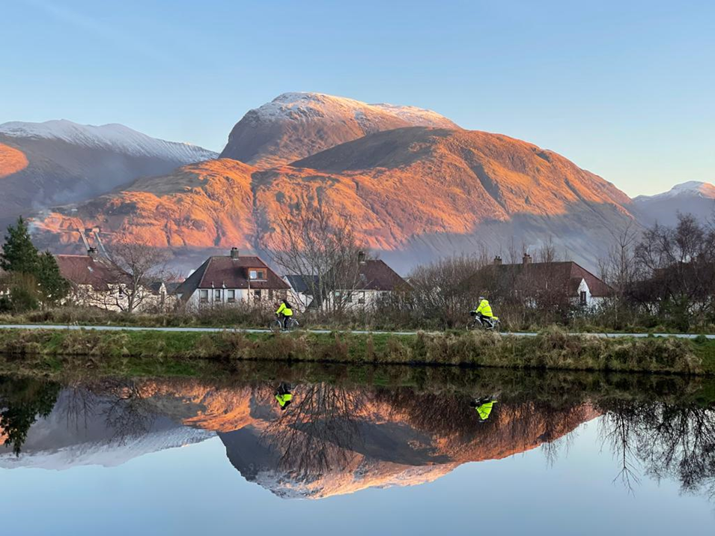
Hybrid event 22nd March 2022: Our Dynamic Earth (Edinburgh) & live stream

Photo by Colleen MacLean

What have Scotland's waters ever done for us? …what can we do for Scotland’s waters?
This event will bring together Scotland’s water sector and water users in their various forms to understand the benefits of Scotland’s water as a resource and the key issues in its management. In aid of Scotland’s vision to be the world’s first Hydro Nation, and meeting commitments following COP26, it will ask: what can we, as individuals and communities of practice, do to protect this precious resource, and how should Scotland’s water community effectively communicate and engage with wider society? These questions will be answered through a series of thematic sessions that will explore this topic through unique insights from policy, research, practise, and personal experience.

Contents
- Event programme
- Participating organisations

1. Event programme

Welcome to World Water Day 2022

09:30 Registration & refreshments

10:00 Welcome
Bob Ferrier, Director of Scotland's Centre of Expertise for Waters, & the Hydro Nation International Centre, James Hutton Institute

10:05 Opening address
Barry Greig, Head of Water Industry Policy, Water Policy & DECC Operations, Scottish Government

Mairi McAllan MSP, Minister for Environment and Land Reform

1. Thematic presentations & roundtable from Scotland’s water community

Chaired by Dr. Rowan Ellis, Senior Policy Officer, Hydro Nation International Centre, James Hutton Institute

10:20h Health & wellbeing of people & the water environment in Scotland’s communities

Improving wellbeing, improving urban waters
Karen Dee, Wastewater Service Strategy General Manager, Scottish Water

There is a strong connection between wellbeing and blue green spaces. What are the steps that we are taking to improve community access through creating blue green spaces in urban environments, and improving our rivers, to make it easier encourage people to enjoy these spaces and the resultant benefits?

Transforming Scotland’s waters
Roy Richardson, River Basin Management Planning Manager, Scottish Environment Protection Agency

People have valued their local water environment more than ever during the pandemic. Scotland’s latest River Basin Management Plan builds on progress and prioritises action to improve urban and rural waters, whilst addressing the challenges of our changing climate. Systemic progress requires partnerships which is why across the next period, we’ll work closely with Scottish Government, Scottish councils, Scottish Water, environment and community groups and others, as together we take the next steps to deliver an even better water environment for our nation.

10:50 The hidden value of water in Scotland

Delivering a sustainable water service in Scotland
Mark Williams, Sustainability and Climate Change Manager, Scottish Water

Water and wastewater services can be resource intense – in the materials to build and maintain the infrastructure, the energy to treat and supply water and wastewater services, and in the use of water resources. But there is also significant value in the recovery and use of energy and resources and management of our land and water catchments. To achieve net zero emissions, we must minimise resource intensity across the managed water cycle and maximise the sustainable value of our assets, services and landholdings.

A low carbon, circular economy water sector – value for all
Amanda Lake, Water Process Lead (Europe), Jacobs

Transitioning to a circular economy offers us an exciting opportunity to realise, retain and recover value from water. We benefit every day from the water cycle – what we enjoy from the tap through the wellbeing benefits of a walk on the canal to the renewable energy, nutrients and more we recover from our recycled water. A Circular Economy water sector would see us do more and support our transition to net zero, providing best value for us all with wider benefits for society and the biosphere. Amanda will showcase hidden benefits and key challenges as we navigate the urban water cycle, summarising recent water industry work on circular economy and resource recovery and highlighting why thinking differently about water, and thinking beyond water is key to safeguarding our precious resource and providing a climate safe future for current and future generations.

11:20 Working with water & communities for better water infrastructure

Blue-green solutions - Why engagement with communities matters and some key principles for carrying it out
Emma Ash, Senior Policy Officer (water), Citizens Advice Scotland

The benefits of engaging communities in the development of blue-green projects will be underlined and why engagement should aim to deliver wider societal benefits from blue-green solutions. We will highlight some of the challenges when using water sector language with members of the public, and the need for simplification. Finally, we will hear from a community who will describe their local blue-green project and how they feel about being involved in its design and delivery.

Scotland’s canals in the twenty-first century: tackling the climate crisis and health inequalities through innovation
Catherine Topley, CEO, Scottish Canals

Scotland is leading the way in managing water innovatively to address the climate crisis and improve people’s lives – but we need to do more. The regeneration of North Glasgow shows that canals can be used to mitigate flood risk and tackle health inequalities through effective partnership working, and long-term visioning to that puts people and planet at the heart of regeneration. The question now is: how do we make sure the rest of Scotland learn from this success and export this knowledge internationally to not only improve the lives of millions of people, but contribute to widespread use of canals as a nature-based solution to climate change?

12:10h Roundtable discussion with speakers
This discussion will centre on the question of how Scotland’s water community can better inform and engage with wider society. The aim, through a facilitated discussion and questions from the audience, is to consider principles for enhancing communication with the public about Scotland’s water management while stimulating positive engagement for sustaining our water resources.

Facilitated by Dr. Rowan Ellis, Senior Policy Officer, Hydro Nation International Centre, James Hutton Institute

Online questions moderated by Hydro Nation Scholars

13:00 Lunchbreak (networking & exhibitions)

In-person attendees at Our Dynamic Earth

‘Groundwater – Home and Abroad’ exhibition
British Geological Survey

The Hydro Nation Chair research & innovation programme - bringing Scotland’s water sector together towards net zero & beyond
Hydro Nation Chair Team

Forth Environmental Resilience Array (Forth-ERA)
University of Stirling

Water Words: Communicating the water cycle
SEFARI Gateway’s Responsive Opportunity Scheme

Online attendees

World Water Day 2022 virtual exhibitions
These virtual tours highlight how Scotland, as an aspiring Hydro Nation, is working across the water sector to respond to the challenges such as climate change. Please explore this rich resource here. Many of tours link with the Hydro Nation Virtual Water Pavilion launched at COP26.

2. Youth roundtable & Scotland the Hydro Nation at home and internationally

Chaired by Professor Lorna Dawson, Principal Scientist & SEFARI Gateway Knowledge Exchange Lead for Environment , James Hutton Institute

14:00h Roundtable: How to engage youth in our shared water challenges?
This roundtable will include several budding advocates and early career professionals in the water sector. It will explore perspectives about communicating the current and future water challenges and seek to establish a starting point for intergenerational dialog about how we value Scotland’s waters.

Session co-facilitators:
Julze Alejandre, Hydro Nation scholar and CREW policy fellow, health promotion specialist, Glasgow Caledonian University
Rita Noelle Moussa, Hydro Nation Scholar and PhD researcher at the University of Aberdeen

Video introduction provided by Laura Young, zero waste advocate

Panellists:
Marissa Wong, Biologist & Engagement/Education, Clyde River Foundation
Logan Stewart, Specialist Graduate in Corporate Affairs, Scottish Water
Gabrielle Guevara, Development Worker & Environmental Planner, current MSc student in
Sustainable Cities, Kings College London
Daniel Atton Beckmann, Hydro Nation PhD Student, University of Stirling

14:50h Re-discovering groundwater: A collaborative journey towards a sustainable water
future in Malawi (video presentation)
Introduced by Muthi Nhlema (BASEflow), on behalf of the Malawi-Scotland
Regulatory Partnership collaborators

15:00h Water wall in motion (see the full water wall here)
Presented by Rachel Helliwell, CREW Manager, Scotland's Centre of Expertise for Waters. Awards for video competition to be announced during refreshment break.

15:10h Refreshments & networking

15:40h Hydro Nation Chair –Bringing Scotland’s water sector together towards net zero
& beyond
Andrew Tyler, Hydro Nation Chair, University of Stirling

16:00-16:10h Summary & close of main World Water Day 2022 event
Jon Rathjen, Deputy Director, Water Policy & Directorate of Energy and Climate Change Operations, Scottish Government

Evening Event: Scotland's Centre of Expertise for Waters Annual Lecture 2022

***Separate registration is required for this event and can be found here***

16:30h Reception with refreshments & networking

18:00h CREW Lecture (live stream will re-commence)
Water science supporting policy- reflections and future challenges
Professor Alan Jenkins, Deputy Director and Science Director, UK Centre for Ecology & Hydrology, chaired by Professor Bob Ferrier, Director of Scotland's Centre of Expertise for Waters, & the Hydro Nation International Centre, James Hutton Institute
19:00h Event close

3. Contributing organisations (click logos for more info.)
